Retention Scheduler
Use Case Specification

Submitted to:

Asst. Prof. Ma. Rowena C. Solamo
Faculty Member
Department of Computer Science
College of Engineering
University of the Philippines, Diliman

Submitted by:
Neil Jonathan Joaquin
David Paul Relao
Aldrin Simpao

In partial fulfillment of academic requirements
for the course
CS 191 Software Engineering I
of the
1st Semester, AY 2014-2015

Revision Control

History Revision:
Revision Date | Person Responsible | Version  Number | Modification
10/02/2014 | Neil | 1.0 | Initial Document: Use-Case specifications
10/02/2014 | Neil | 2.0 | Added activity diagrams
10/03/2014 | David | 3.0 | Revisions: Use-Case descriptions elaborations. Use-Case preconditions.

Use-Case Name: Manage Activities

Description: Overall event handler. It manages all the events in your calendar. An interface in which you are given three options either you add an event, edit an event or delete an event.

Preconditions: None

Flow of Events:
Scenario Name | Description
Scenario 1 (Basic Flow)  User wants to add an event. | User will enter all needed information such as name of event, date and time of event, and description of event.
Scenario 1 (Basic Flow)  User wants to edit an event. | User will be shown a list of all events he added where he can click the information regarding the event, i.e., the name of event, date and time of even, and description of event; and they can be edited if he sees the need to edit for further updates on the event.
Scenario 1 (Basic Flow)  User wants to delete an event. | User will be shown a list of all events he added in which he can easily delete any event by clicking it.

Activity Diagram:

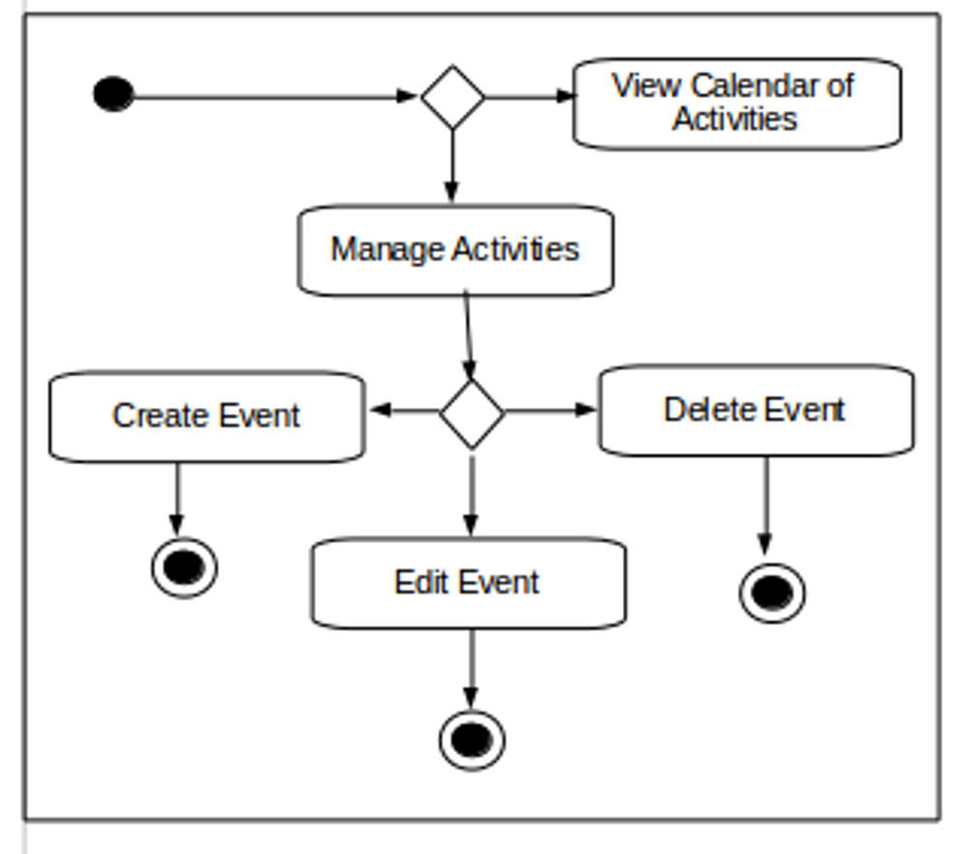
Postcondition: None.

Relationships: Create Event
Edit Event
Delete event

Special Requirements: None

Use-Case Name: Create Event

Description: Creates an event that is not yet present in the current events list. In which you will be required to add the name of event, and date & time of event. In addition, associating notes/slides into the event is optional, i.e., the user can freely add notes/slides when he needs to.

Preconditions: Each event must have a unique name.

Flow of Events:
Scenario Name | Description
Scenario 1 (Basic Flow)  User creates an event | User will enter all needed information such as name of event, date and time of event, and description of event before he can save the save it to the calendar of activities.

Activity Diagram:
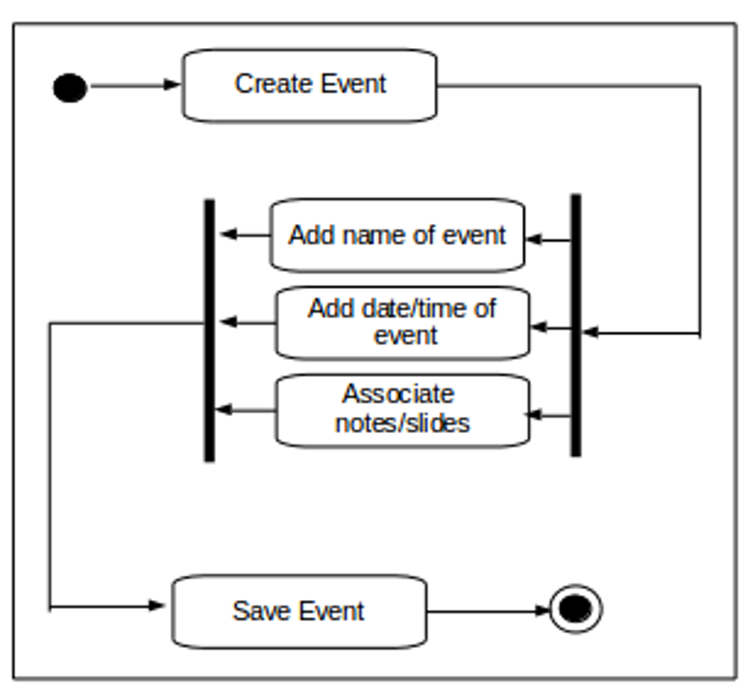

Postcondition: None

Relationships: Save event

Special Requirements: None

Use-Case Name: Edit Event

Description: Modifies an existing event in the calendar of activities, in which the user can edit the name of an event, date & time of an event and edit the slides/notes associated with the event if there is any.

Preconditions: Event must be existing in the calendar of activities.

Flow of Events:
Scenario Name | Description
Scenario 1 (Basic Flow)  User edits an event | User will be shown the information regarding the event, i.e., the name of event, date & time of event, and associated slides/notes if they are any; then, the user can edit the information incorporated in that event. Finally, the user can save the event after.

Activity Diagram:
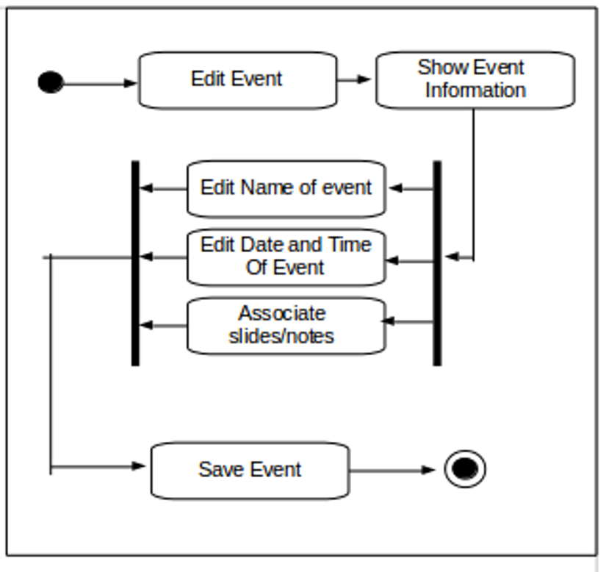
Postcondition: None

Relationships: Save event

Special Requirements: None

Use-Case Name: Delete Event

Description: Deletes an event in the calendar of activities, i.e., the user can choose from the calendar an event to delete.

Preconditions: Event must be existing in the calendar of activities.

Flow of Events:
Scenario Name | Description
Scenario 1 (Basic Flow)  User deletes an event | User will be shown the list of events from the calendar of activities; then he can choose and delete any of these events. In addition to that, deleting the said event/s will result in deletion of all the event’s information.

Activity Diagram:
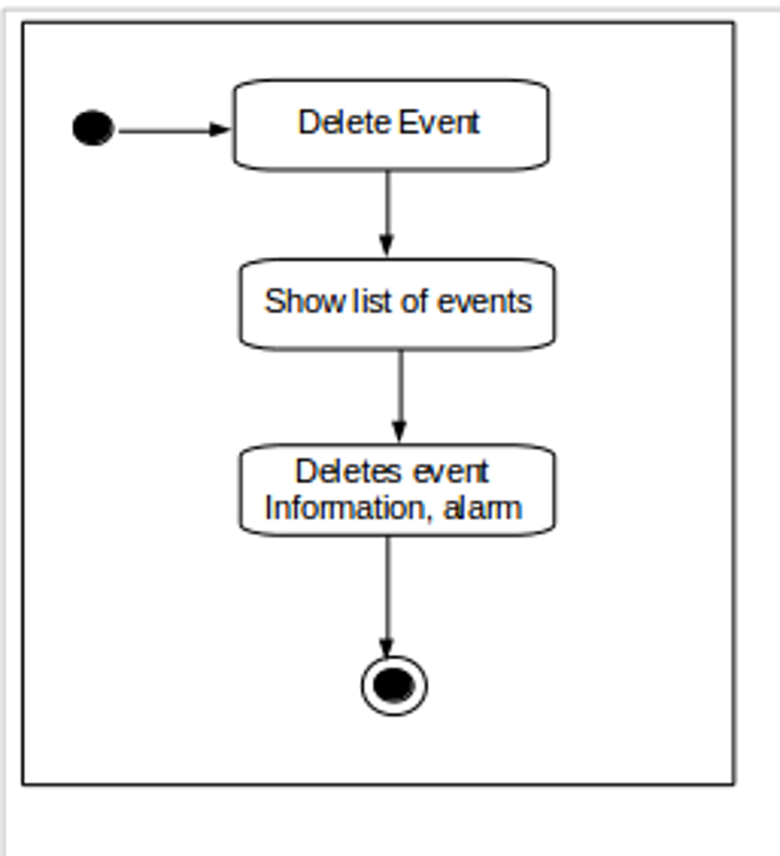

Postcondition: None

Relationships: None

Special Requirements: None

Use-Case Name: Save Event

Description: Saves the changes made in an activity or event. Also, this adds the event to the calendar of activities. In addition, the program creates an alarm for the event. Moreover, if the user has just only created an event, this also saves that event to the calendar of event.

Preconditions: User must be creating, adding, or editing an event to the calendar of activities.

Flow of Events:
Scenario Name | Description
Scenario 1 (Basic Flow)  User saves an event | Program will save event to the database, adds it to the calendar of activities, and creates an alarm for the said event incorporating the event’s informtion.

Activity Diagram:
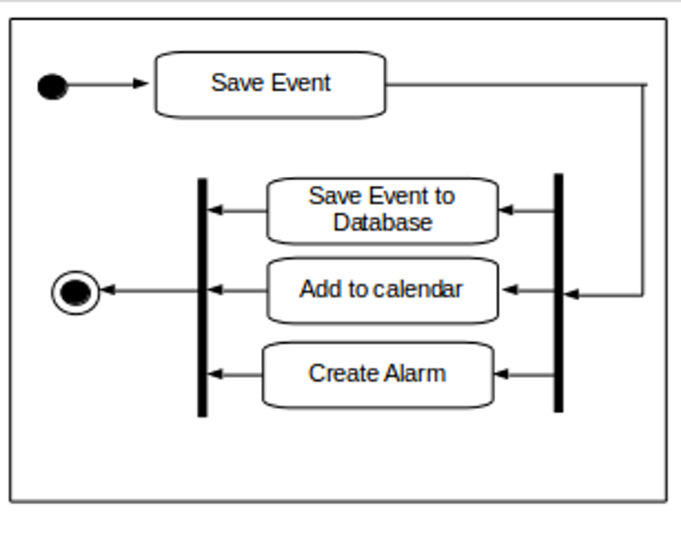
Postcondition: None

Relationships: None

Special Requirements: None

Use-Case Name: Associate Slides/Notes

Description: Adds an existing slides, text file/s, or any other digital links to the event in the calendar of activities.

Preconditions: User must be creating, adding, or editing an event in the calendar of activities.

Flow of Events:
Scenario Name | Description
Scenario 1 (Basic Flow)  User associates slides/notes  to the event | User is shown a list of files in his smartphone; then, he may opt to associate one or more files with an event in the calendar of activities.

Activity Diagram:
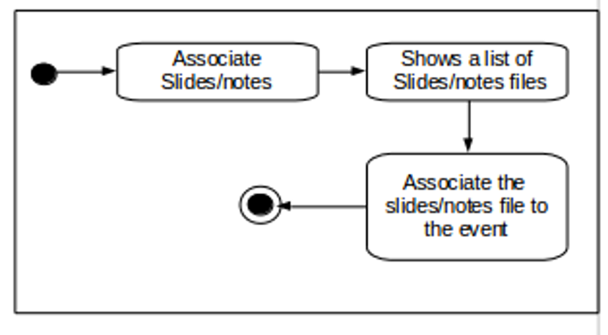

Postcondition: None

Relationships: None

Special Requirements: None

Use-Case Name: View calendar of events

Description: Displays all the events in a particular month of the year in the calendar of activities.

Preconditions: None

Flow of Events:
Scenario Name | Description
Scenario 1 (Basic Flow)  User views calendar of events | User is shown a calendar of activities in month-view with the events plotted in it.
Scenario 2  User wants to view events of the week | User is shown a calendar of activities in week-view with the events plotted in it.
Scenario 2  User wants to view events of the day | User is shown a list of events that is due on that specific day in the calendar of activities.

Activity Diagram:
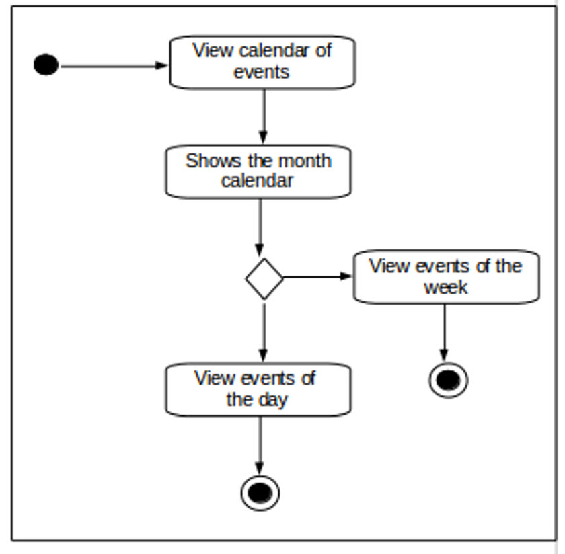
Postcondition: None

Relationships: View events of the week
View events of the day

Special Requirements: None

Use-Case Name: View events of the week

Description: Displays all the events per day in a particular week specified by the user.

Preconditions: User is in the View calendar interface.

Flow of Events:
Scenario Name | Description
Scenario 1 (Basic Flow)  User views week calendar | User is shown a calendar of activities in week-view with the events plotted in it.
Scenario 2  User wants to view events of the day | User is shown a list of events that is due on that specific day in the calendar of activities.

Activity Diagram:
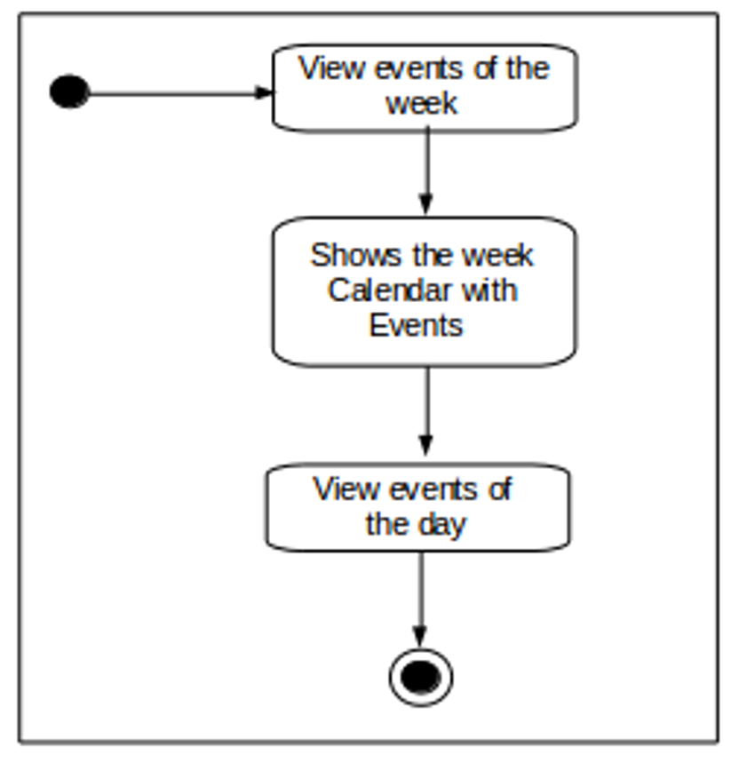

Postcondition: None

Relationships: View events of the day

Special Requirements: None

Use-Case Name: View events of the day

Description: Displays all the events plotted/listed in a particular day specified by the user.

Preconditions: User is in the View calendar interface.

Flow of Events:
Scenario Name | Description
Scenario 1 (Basic Flow)  User views events of the day | User is shown a list of events that is due on that specific day in the calendar of activities.

Activity Diagram:
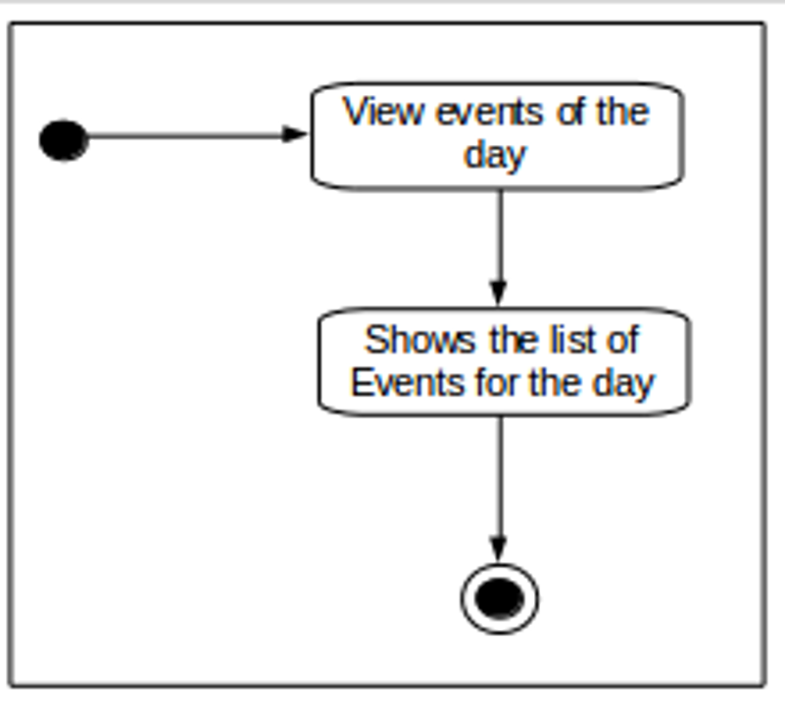
Postcondition: None

Relationships: View events of the day

Special Requirements: None

